The Crim Open Campus Mathematics Team is soaring like the Eagle!
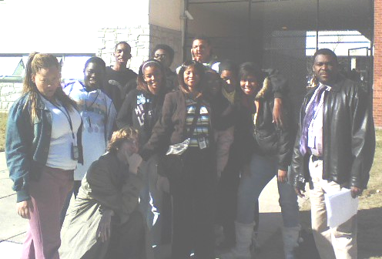
The following members of the Crim Open Campus (OC) Mathematics Team competed in Round I of the Atlanta Public Schools’ Andover Dartmouth Mathematics Competition held on November 29th at North Atlanta High School:
Randy Adams
Dominique Dawson
Qymoan Davis
Brittany Etheridge
Adrian Harris
Tanya Henderson
Vanessa Huff
Stephen Jenkins
Angelo Jones
Galen Roberts
Ian Sexton
Jasmine Swanson

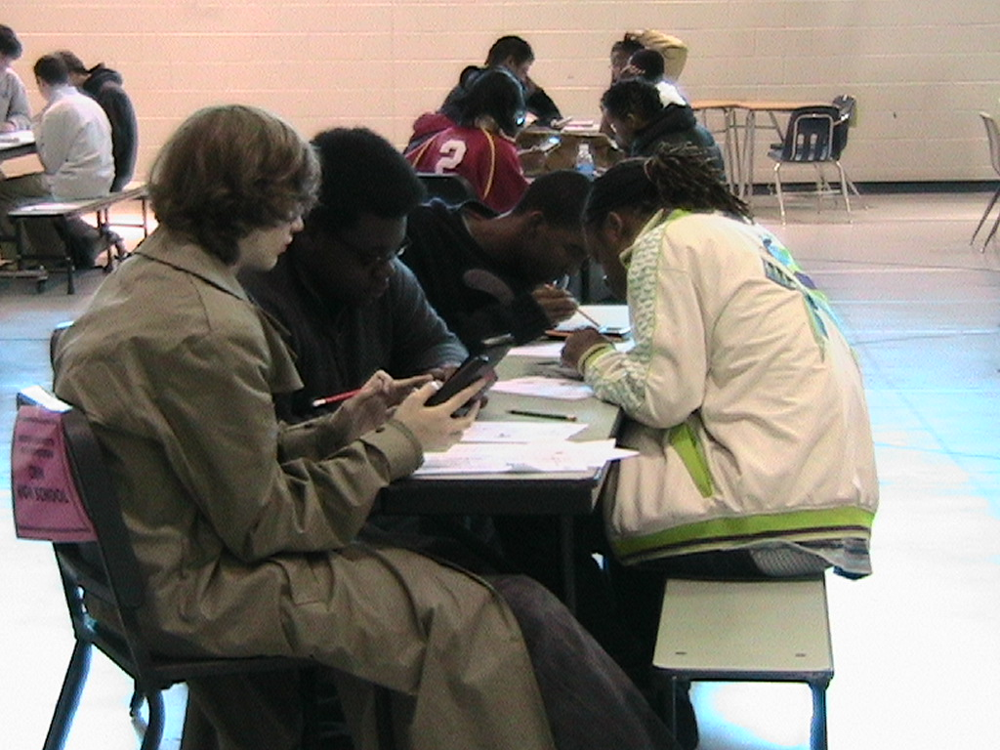
Senior Division team members Ian Sexton, Stephen Jenkins, Angelo Jones and Galen Roberts collaborate on group test during Andover Competition
OC Math Team pose in front of North Atlanta High School with team sponsors Ms. J. Rainey and Mr. L. Clarke.

The Crim OC Mathematics Team participated in all three categories of competition which were: Novice (Algebra I), Junior (Geometry and Algebra II), and Senior (Advanced Algebra /Trig and beyond). Students had to take an individual test, a group test and a ciphering test. The results from this exciting competition have not yet been released.

This is the third mathematics competition that the Crim OC Mathematics Team has participated in this school year. Earlier this year, Crim Open Campus High School was the only Atlanta Public school represented at the North Fulton Varsity Mathematics Tournament held Saturday, September 29, 2007 at Alpharetta High School. The Crim OC Mathematics Team also competed in the Kennesaw State University (KSU) Mathematics Competition that was held on November 7, 2007. A total of 2369 students from 113 high schools in 49 counties and Atlanta City took part. OC mathematics team member Galen Roberts scored in the 82nd percentile on the KSU exam and earned the honor of being the highest scoring student at Crim Open Campus High School.

The Crim OC Mathematics Team is soaring like an eagle!
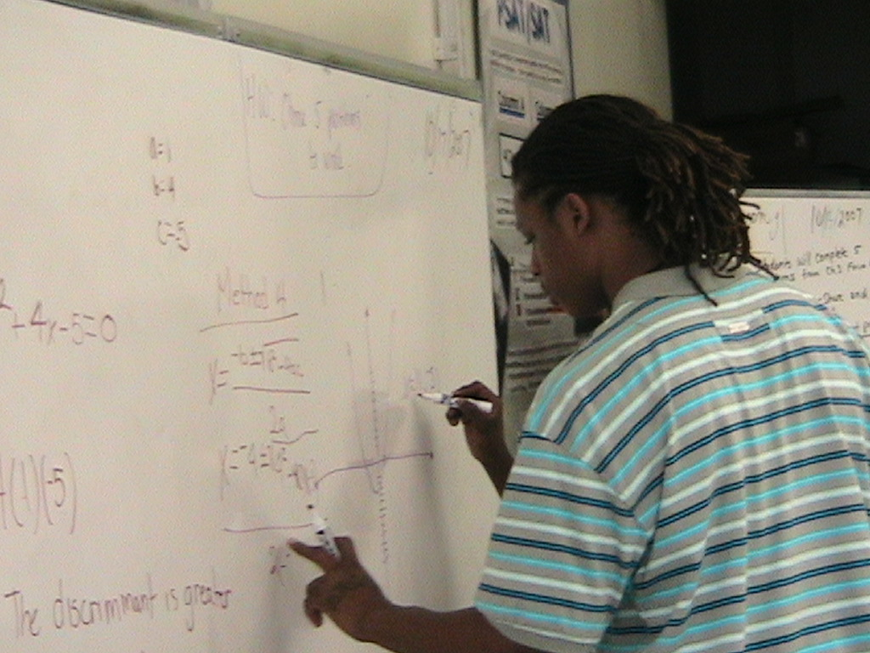

Sierra Luttery and Chiquita Yancey pose with students at North Fulton Varsity Mathematics Competition
Galen Roberts earns highest score at Crim Open Campus on 2007 Kennesaw State Univ. Mathematics competition.

