MATH TEAM FORMULA SHEET 2007-2008
RIGHT TRIANGLES

Pythagorean Theorem:

Geometric relationships:
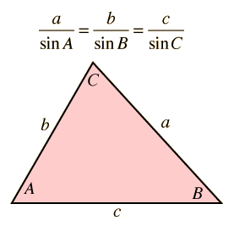
Median to hypotenuse:

GENERAL TRIANGLES

Law of Sines:

Law of Cosines:

Inscribed and Circumscribed Circles

K = area of ∆ABC
r = radius of inscribed circle
R = radius of circumscribed circle = 2r

Area of triangle:
Heron’s Formula:
Inscribed Radius:
Circumscribed Radius:
Area, K, is the sum of three smaller triangles, ∆AOC, ∆COB, and ∆BOA.
Area of ∆AOC =
Area of ∆COB =
Area of ∆BOA =

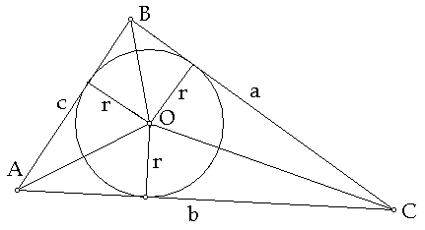

Altitude
Altitudes of a triangle intersect at orthocenter

Angle Bisector
Angle Bisectors meet at the incenter, center of triangle’s inscribed circle

Angle Bisector Theorem:
Length of Angle Bisector:

Median
Medians of a circle intersect at centroid
Along the median, distance from a vertex to centroid is twice distance from centroid to opposite side

Length of Median:

Angle Measurements

CIRCLES
Two Secants
Intersecting chords
Inscribed Angles
Two intersecting chords
Two secants: Secant and tangent:

REGULAR POLYGONS
Sum of Interior Angles:
Interior Angle Measure:
Area:
n = number of sides in the polygon
s = length of each side
= measure of one of the interior angles
r = radius of inscribed circle
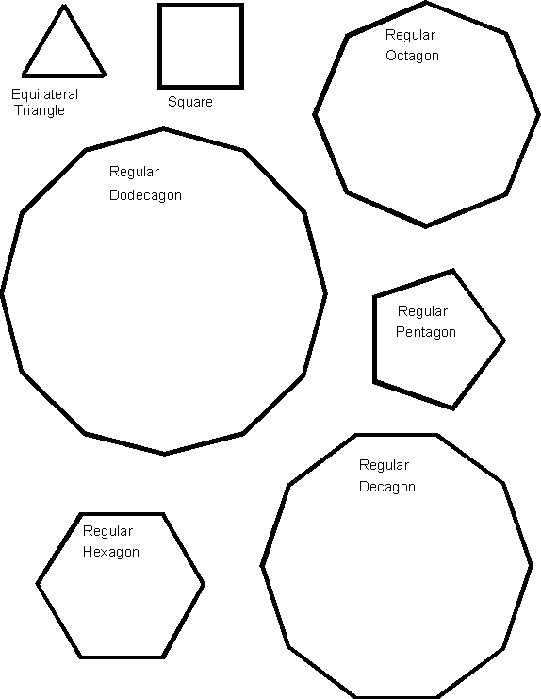
R = radius of circumscribed circle

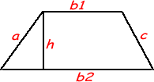
AREAS AND VOLUMES
Parallelogram: Area = bh Triangle: Area = Trapezoid:

Rctangular Solid

Rectangular Solid
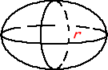
Surface Area:
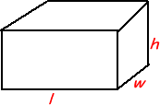

Volume:

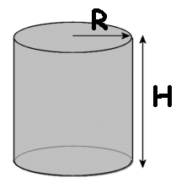

Pyramid
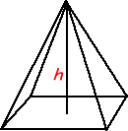

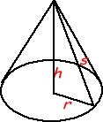

POINTS AND LINES
For points P₁(x₁,y₁) and P₂ (x₂,y₂) in rectangular coordinate plane:

Distance between P₁ and P₂:
Slope m:
Angle between two lines of slopes m₁ and m₂:
Distance Formula: Distance (d) from Point P₁ (x₁,y₁) to Line of form:

Midpoint Formula for midpoint between P₁ (x₁,y₁) and P₂ (x₂,y₂)

TRIANGLES

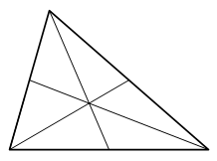

CONIC SECTIONS

PARABOLA : for a given point (the focus) and a given line not through the focus (directrix), a parabola is the locus of points such that the distance to the focus equals the distance to directrix
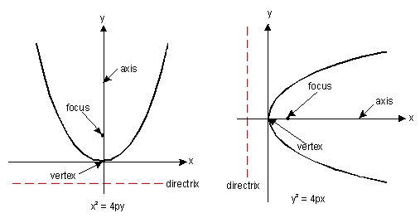
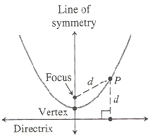

CIRCLE: A circle is the locus of all points equidistant from a central point.
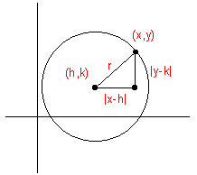
(x - h)² + (y - k)² = r ²

ELLIPSE: the locus of points P such that the distances from P to two fixed points is a constant; 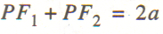

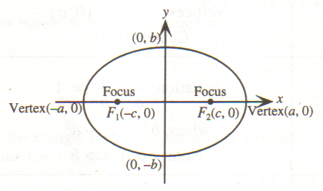
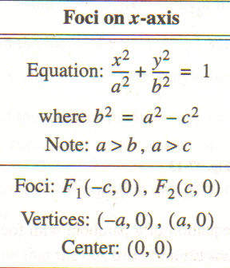

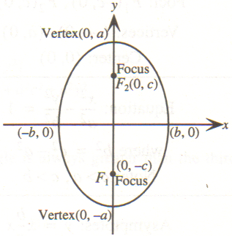
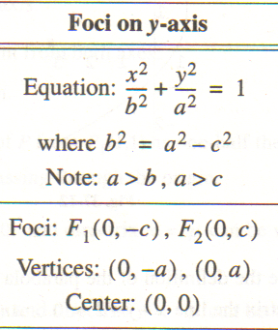

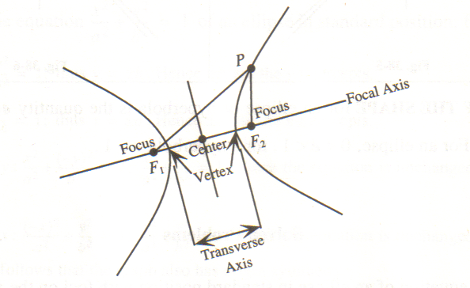
HYPERBOLA: the locus of points P such that the absolute value to the difference of the distances from P to two fixed points is constant; 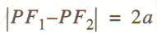

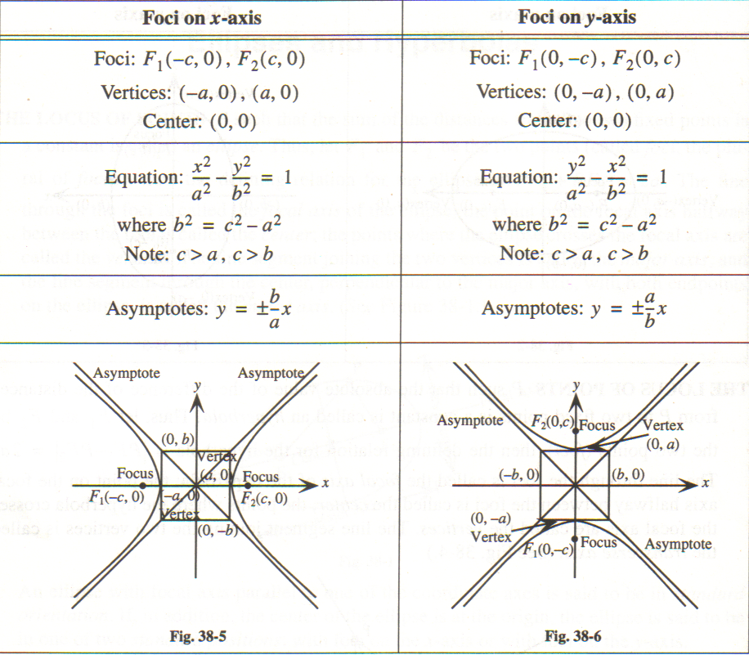

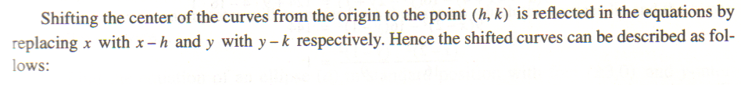

EQUATIONS FOR CONIC SECTION CURVES
Curve | General Equation | Notes | Example
Circle |  | center of circle = (h, k)  radius = r | x² + y² = 49
Ellipse |  | length of major axis = 2a  foci at c and –c  b² = a² –c²  center = (h, k) | x² + 25y² = 49
Hyperbola |  | foci at c and –c  a² + b² = c²  center = (h, k)  equation of asymptotes: y = ±(b/a)x
Parabola |  | axis of symmetry: x = h  vertex = (h, k) | (x-7)² + 1 = y
POLYNOMIALS

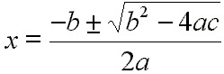
Quadratic Formula for ax²+bx+c=0

PROBABILITY

BINOMIAL EXPANSIONS: binomials or other two term quantities raised to integer powers
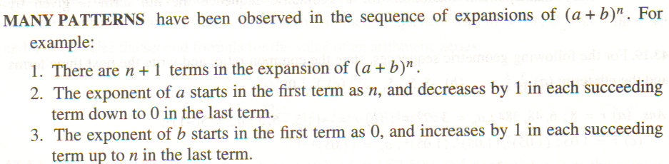
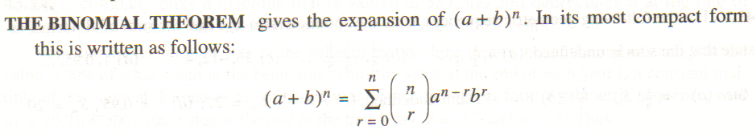
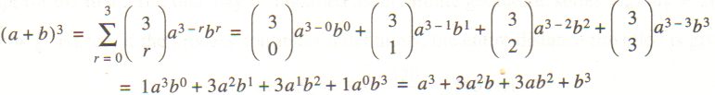

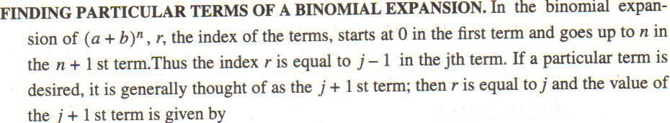
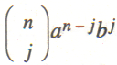
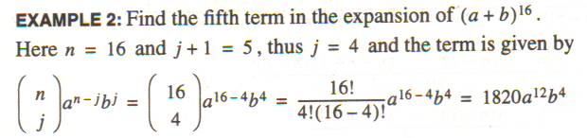

Find the sum of the coefficients of expanded form of (x+2y)⁵
Fast Way: Add coefficients of x and y and then raise to the power ; in this case, 1+2=3; 3⁵=243

INTEREST RATES

Simple Interest
The simple interest I on an amount of P dollars for t years at interest rate r per year is I=Prt .

The future value A of P dollars at simple interest rate r for t years is A = P(1 +rt).

The present value P of a future amount of A dollars at simple interest rate r for t years is P = A .
1 + rt
If D is the discount on a loan having maturity value A at simple interest rate r for t years, then D = Art .
If D is the discount and P the proceeds of a loan having maturity value A at simple interest rate r for t years,
then P = A – D or P = A(1 – rt ).

Compound Interest
If P dollars is deposited for n time periods at compound interest rate i per period, the compound amount (future value) A is A = P( 1 + i )^{n}.

The present value P of A dollars at compound interest rate i per period for n periods is
P = A = A(1 + i) ^{–n}.
(1 + i )^{n}

The effective rate corresponding to a stated interest rate r per year, compounded m times per year, is
r_{e} = ( 1 + ^{r}/_{m} )^{m} – 1.

Continuous Compound Interest
If P dollars is deposited for t years at interest rate r per year, compounded continuously, the compound amount (future value) A is A = Pe ^{rt} .

The present value P of A dollars at interest rate r per year compounded continuously for t years is P = A .
e^{rt}

ARITHMETIC AND GEOMETRIC SEQUENCES

